INFR 3110U: Assignment 1

Boris Au  
ID: 100660279GDW: Ariaware  
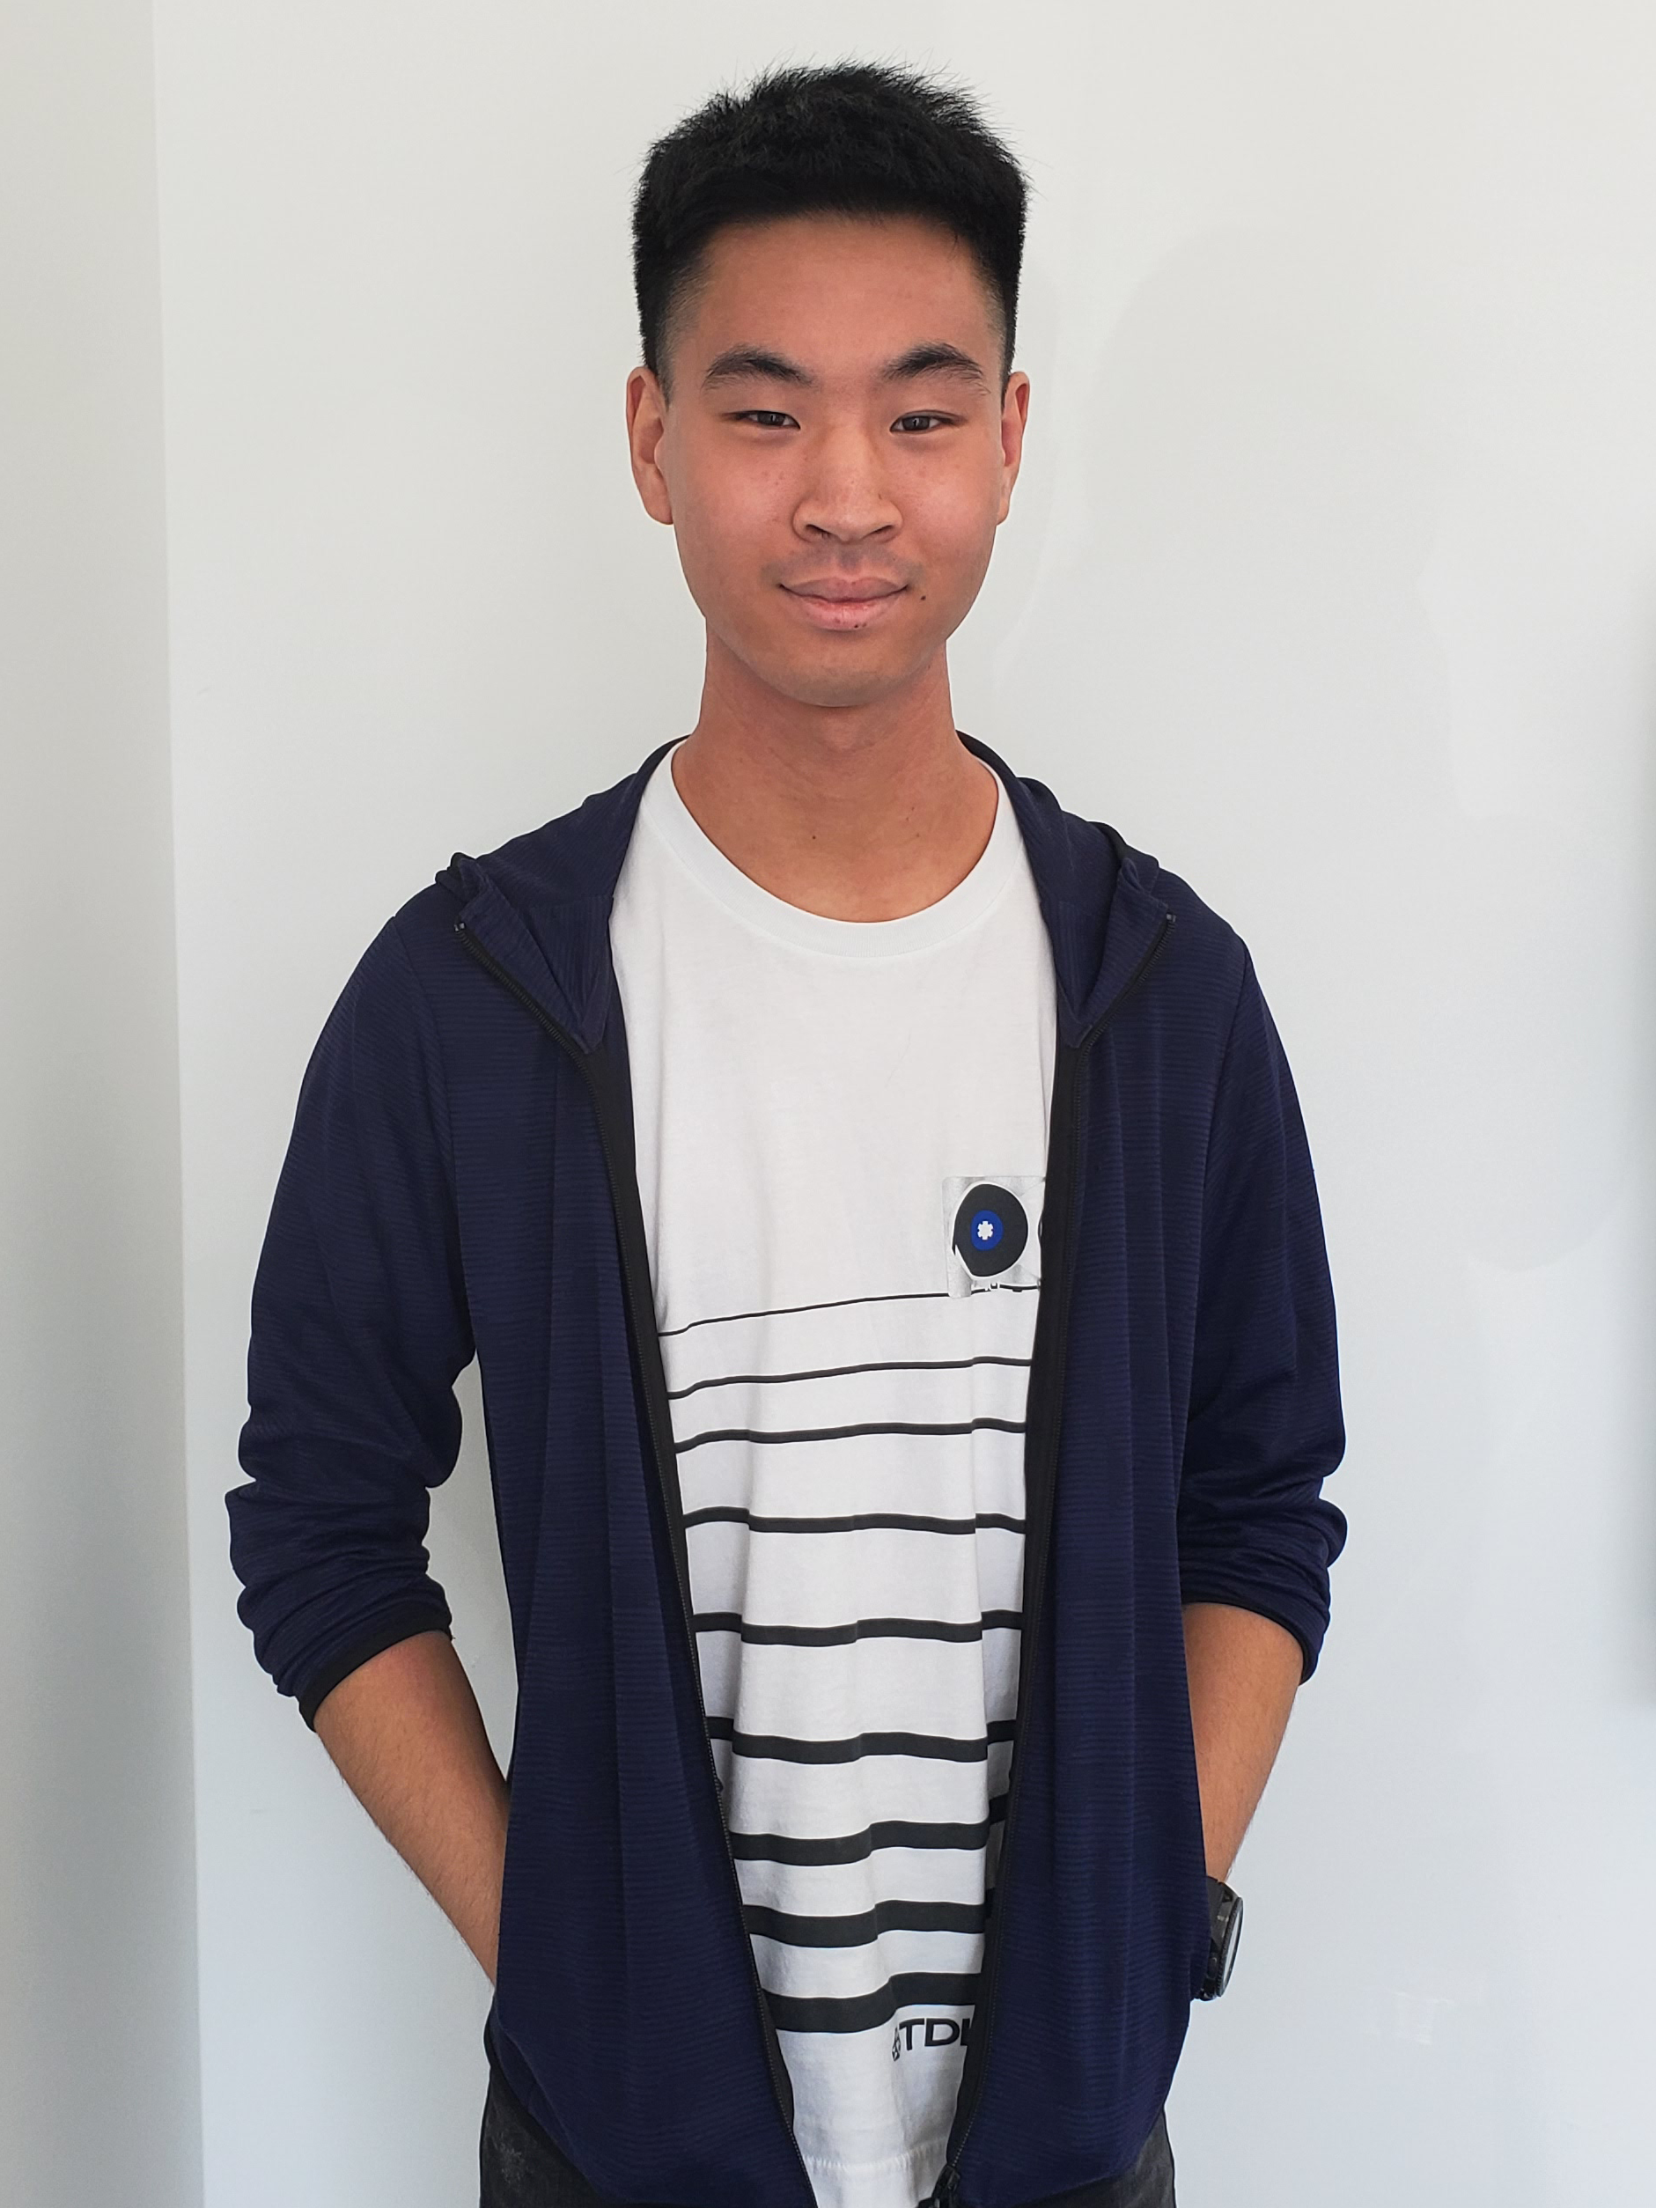

  
John Wang  
ID: 100657681GDW: Ariaware  


  
Victor Zhang  
ID: 100421055GDW: Ariaware  




# Table of contents

1. Introduction
2. Design Patterns
   1. Command Design Pattern
   2. Factory Design Pattern
   3. Singleton Design Pattern (DLL)
   4. Game Loop Pattern
3. Pseudocode/UML
4. Implementation
   1. Saving and Loading the map
   2. External Camera Script
5. Screenshots and References

*Abstract*—This document outlines how our level editor works along with descriptions of how the different design patterns are used.

# Introduction

Our level editor allows all members of our GDW team to place objects anywhere in the scene and save the data to a text file.

# Design Patterns

## Command Design Pattern

First, confirm that you have the correct template for your paper size. This template has been tailored for output on the A4 paper size. If you are using US letter-sized paper, please close this file and download the Microsoft Word, Letter file.

## Factory Design Pattern

The template is used to format your paper and style the text. All margins, column widths, line spaces, and text fonts are prescribed; please do not alter them. You may note peculiarities. For example, the head margin in this template measures proportionately more than is customary. This measurement and others are deliberate, using specifications that anticipate your paper as one part of the entire proceedings, and not as an independent document. Please do not revise any of the current designations.

## Game Loop Pattern

# Pseudocode/UML

Before you begin to format your paper, first write and save the content as a separate text file. Complete all content and organizational editing before formatting. Please note sections A-D below for more information on proofreading, spelling and grammar.

Keep your text and graphic files separate until after the text has been formatted and styled. Do not use hard tabs, and limit use of hard returns to only one return at the end of a paragraph. Do not add any kind of pagination anywhere in the paper. Do not number text heads-the template will do that for you.

# Implementation

## Saving and loading the level

Both saving and loading the level in our editor involves interfacing with a text file. We created a dll called MapLoader.dll to facilitate the save and loading of data. Our level data text file holds four float each line separated by a ‘,’. The first element specifies the object and the subsequent three values contain the X, Y, and Z positions.

## Identify the Headings

Headings, or heads, are organizational devices that guide the reader through your paper. There are two types: component heads and text heads.

Component heads identify the different components of your paper and are not topically subordinate to each other. Examples include Acknowledgments and References and, for these, the correct style to use is “Heading 5”. Use “figure caption” for your Figure captions, and “table head” for your table title. Run-in heads, such as “Abstract”, will require you to apply a style (in this case, italic) in addition to the style provided by the drop down menu to differentiate the head from the text.

Text heads organize the topics on a relational, hierarchical basis. For example, the paper title is the primary text head because all subsequent material relates and elaborates on this one topic. If there are two or more sub-topics, the next level head (uppercase Roman numerals) should be used and, conversely, if there are not at least two sub-topics, then no subheads should be introduced. Styles named “Heading 1”, “Heading 2”, “Heading 3”, and “Heading 4” are prescribed.

### For papers with more than six authors: Add author names horizontally, moving to a third row if needed for more than 8 authors.

### For papers with less than six authors: To change the default, adjust the template as follows.

#### Selection: Highlight all author and affiliation lines.

#### Change number of columns: Select the Columns icon from the MS Word Standard toolbar and then select the correct number of columns from the selection palette.

#### Deletion: Delete the author and affiliation lines for the extra authors.

# Screenshots and References